**SURVEY OF INDIAN SOILS**

Soil is an integral source of nutrients to plants in agriculture. Healthy soil is essential for life, as they provide nutrients for plant growth, habitat for many insects and other organisms, acts as a filtration system for surface water and also maintains atmospheric gases. In India the soil types are classified as follows:

* Alluvial soil
* Red soil
* Black / Regur soil
* Arid / desert soil
* Laterite soil
* Saline soil
* Peaty / marshy soil
* Forest soil

**ALLUVIAL SOIL:**

These are fertile soil deposited by rivers on and near their banks. These soils are majorly found in the northern plains of the country. The most fertile alluvial soil is found in the Ganga valley, where it is deposited by river Ganges. These soils cover almost 35-40% of the region of India. These soils are rich in minerals especially potash. They are a dark shade of grey and are extremely suitable for agriculture. Some dark black alluvial soil can also be found in coastal areas.

**RED SOIL:**

These distinct soils are named after their hues. Red soil gets its colour from the iron found in its composition in a crystallized form. The soil takes on a yellow colour when it is hydrated. These soils are generally found in the Western Ghats, Odisha and Chattisgarh. The clay form of red soil is nutrient rich and viable for forestation. However coarse red or yellow soil has been completely leached of all its nutrients and is not fertile. Red soil actually has a very low level of humus and requires fertilizers when used for farming.

**BLACK SOIL:**

Black Soil is characterized by their deep black colour. Their composition has a large amount of clay. This helps the black soil retain water, making them ideal for crops that require water year round. This also gives them a unique self-ploughing ability. These soil are rich in lime, iron and magnesia. They are mainly found in the Deccan Plateau in Maharashtra, Madhya Pradesh, Gujarat etc. They are also known as Black Cotton Soil, since cotton grows exclusively in black soil, and is one of the main cash crops in India.

**LATERITE SOIL:**

Such soils are found in regions of high temperature and very high rainfall. The rains will wash all the nutrients from the soil, leaving it infertile. The leaching process will leave behind iron-rich soil, absent of silicon. The humus composition is also affected by bacteria and fungi that thrive in high temperatures. Such soils are found in the hot and humid regions of Western Ghats, Eastern Ghats, Malwa Plateau, Tamil Nadu, Kerala etc. While these soils are not entirely suitable for agriculture they have other uses. they are used to make bricks which we use in constructions.

**ARID SOIL:**

These are the sandy soils that appear in extremely dry and arid regions of Rajasthan and Gujarat. These soils are completely void of any organic matter. They also have a very high saline content, making them largely infertile. Only desert vegetation (cacti, bushes etc) can grow in this type of soil.

**SALINE SOIL:**

These are also known as Usara soils. As the name suggests they have a very high saline content in their composition. They also have large quantities of potassium and magnesium, making them infertile. These soils are found both in dry regions and in swamps.

|  |  |  |  |  |
| --- | --- | --- | --- | --- |
| **TYPE OF SOIL** | **STATE** | **RICH IN** | **LACKS** | **CROPS GROWN** |
| Alluvial | Mainly found in the plains of Gujarat,  Punjab, Haryana, UP, Bihar, Jharkhand etc. | Potash and Lime | Nitrogen and Phosphorous | Large variety of rabi and kharif crops such as wheat, rice, sugarcane, cotton, jute etc |
| Black soil | Deccan plateau- Maharashtra, Madhya Pradesh, Gujarat, Andhra Pradesh, Tamil Nadu, Valleys of Krishna and Godavari | Lime, Iron, Magnesia and Alumina, Potash | Phosphorous, Nitrogen and organic matter | Cotton, sugarcane, jowar, tobacco, wheat, rice etc. |
| Red soil | Eastern and southern part of the Deccan plateau, Orissa, Chattisgarh and southern parts of the middle Ganga plain. | Iron and Potash | Nitrogen, Phosphorous and humus. | Wheat, rice, cotton, sugarcane and pulses |
| Laterite soil | Karnataka, Kerala, Tamilnadu, Madhya Pradesh, Assam and Orissa | Iron oxide and potash | Organic matter, Nitrogen, Phosphate and Calcium | Cashewnuts, tea, coffee, rubber |
| Arid and Desert soil | Western Rajasthan, north Gujarat and southern Punjab | Soluble salts, phosphate | Humus, Nitrogen | Only drought resistant and salt tolerant crops such as barley, rape, cotton, millets maize and pulses |
| Saline and Alkaline soil | Western Gujarat, deltas of eastern coast, Sunderban areas of West Bengal, Punjab and Haryana | Sodium, Potassium, Magnesium | Nitrogen and Calcium | Unfit for agriculture |

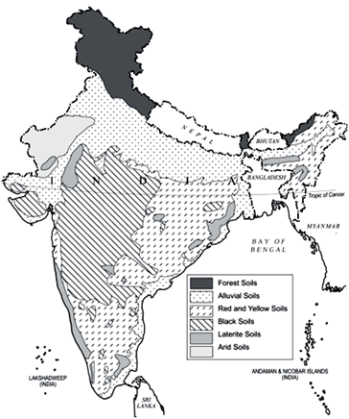

**Fig Soils of India**